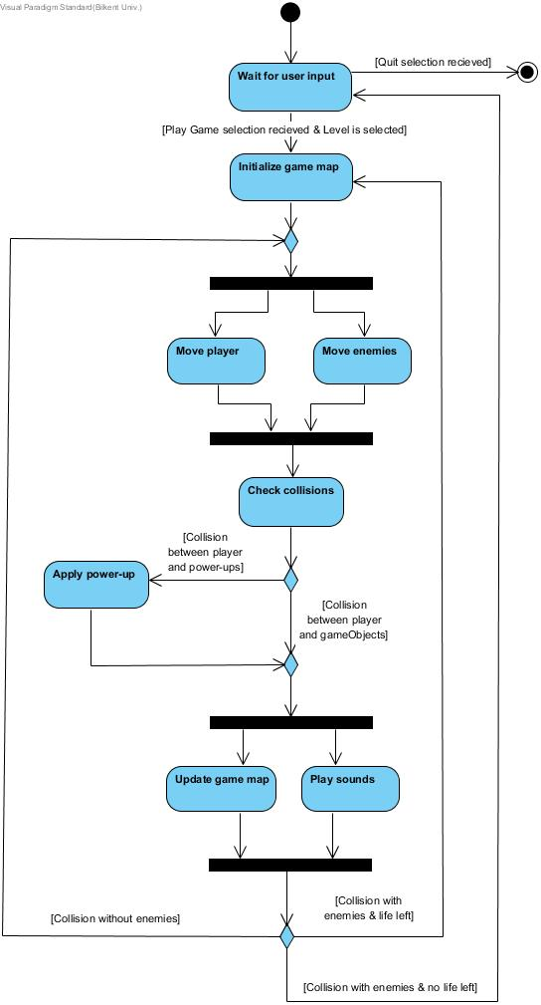

The diagram above shows how the system maintains the gameplay:

When player opens the game, the system displays a main menu for the user and waits for the player input. When player first selects Play Game option and then selects the desired level to play, system initializes the game map and the game starts. According to the player inputs, the system tries to move the main character and the enemies concurrently. Before updating their positions, the system have to check collisions. At first, the system checks collisions between the main character(player) and the game objects. There are two types of this collision. First type is between the main character and power-ups such as hammer, extra life or bonus coin. If this collision appears, the system applies power-ups. The second type is between the main character and the other game objects rather than the power-ups. The system updates game map after checking these collisions because without checking them, the system cannot figure whether the desired movement is possible or not. Also, the system play sounds while it is updating the game map. After this point, the system determines the course of events. If the main character doesn't collide with enemies, the system tries to handle the next movement of the main character and enemies. If the main character collides with enemies but player have remaining lives, the system initializes the game map and starts the game again. If the main character collides with enemies and player doesn't have remaining lives, the system returns to main menu and wait for the player input again. Player can play the game again or he/she can select Quit option to exit game.